Store Clerk

Receive Order Form

Click “Receive Order Form” link from menu to view Receive Order Form screen.

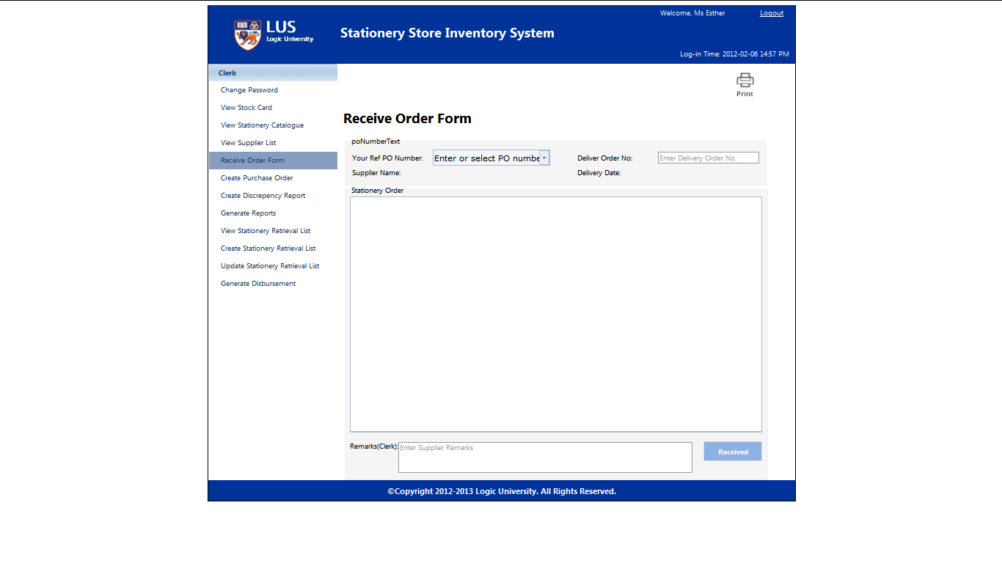

Choose or Enter PO number to view Stationery Order .

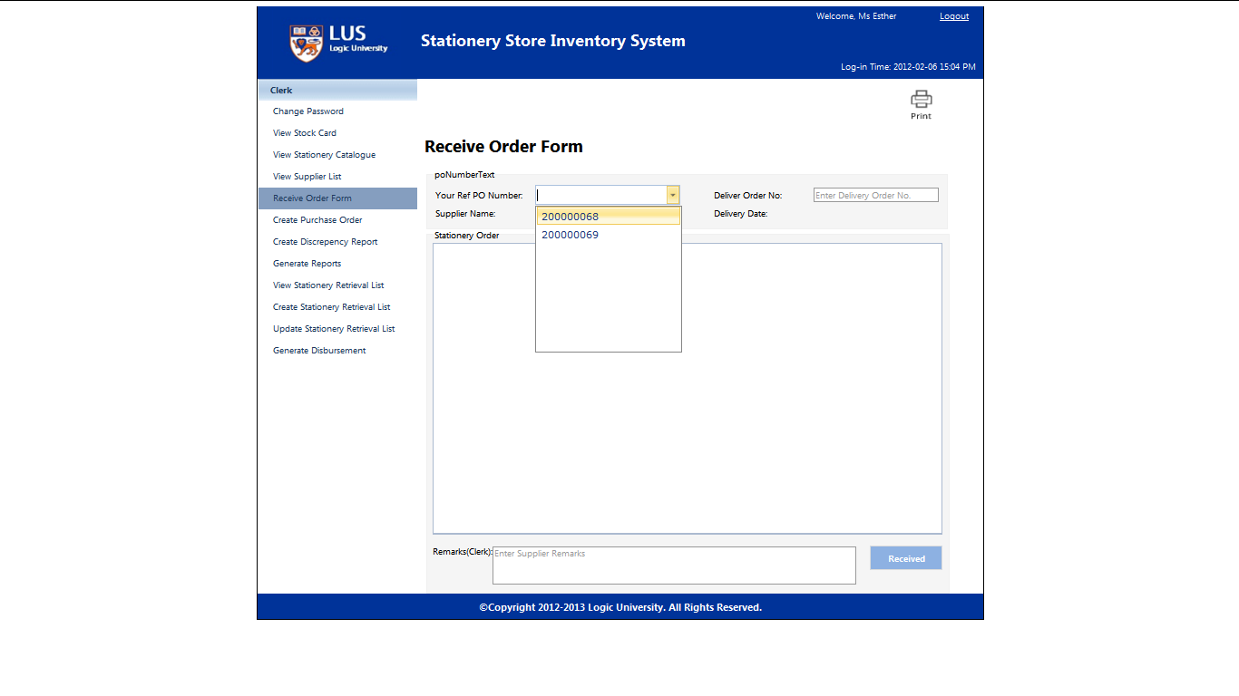

Enter Delivery Order No, Quantity, Remarks(Supplier) and Remark (Clerk) before click the Received button to make the receive order form.

